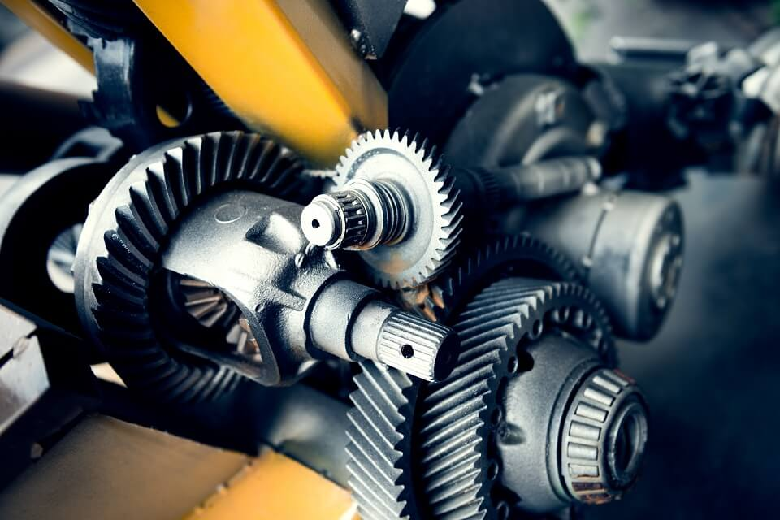

[**Mechanical Integrity, Safety & Reliability**](https://btsconsultant.com/courses/mechanical-integrity-safety-reliability/)

**Training Program**

**Introduction:**

This course will provide a comprehensive review of the various aspects of engineered safety and mechanical integrity in refineries, oil & gas plants and petrochemical plants.

Principal emphasis is placed on the primary means of achieving plant integrity, which is the prevention of pressure equipment and piping failures, particularly, any which could cause significant consequences.

**Training Methodology:**

The course combines sound engineering principles, methods, and applicable codes & standards and best industry practices.  Actual major incidents as well as industry experience will be reviewed in depth to reinforce every topic.

**Organizational Impact:**

* The company will be able to achieve measurable improvement in mechanical integrity through effective interaction between engineering, operation and maintenance functions.
* The company will be able to use risk assessment methodologies to quantify and prioritize risks, and to allocate resources for optimum benefit
* The company will be able to enhance its ability to use risk-based inspection and maintenance resulting in lower life cycle costs while complying with codes and standards, and other regulatory requirements

**Personal Impact:**

* Delegates will enhance their knowledge and expertise in pressure equipment and piping system design, and will be equipped with structured procedures and effective guidelines to perform design calculations.
* Participant will gain a sound working knowledge of the interdependence of design, operation, and maintenance on integrity, reliability and cost-effectiveness of piping systems.
* Participant will extend his/her knowledge of the requirements and application of relevant sections of the ASME Boiler and Pressure Vessel Code and B31 Piping Codes, as well as relevant API Codes, standards, and Recommended Practices such as 571 and 580 in pressure equipment and piping system design, operation, inspection repairs and alterations.
* Participants will add to their ability and skills in piping failure detection and analysis, estimating failure consequences, and fitness-for-service assessment.
* Participants will enhance their competence and productivity thereby enhancing their competence and performance level and making additional value added contributions to their organizations.

**Competencies emphasized:**

**Delegates will enhance their competencies in the following areas:**

* Mechanical design of pressure equipment and piping systems in compliance with applicable codes, standards, and regulations.
* Engineering materials properties and selection criteria for specific applications.
* Identification and assessment of active degradation mechanisms and the failures they may cause.
* Hazard identification and risk analysis and management.
* Application of risk-based methodologies in inspection and maintenance.
* Fitness-For-Services assessments

**Who Should Attend?**

This course is particularly valuable for refinery and petrochemical plant technical managers, engineers, inspectors, maintenance personnel, as well as for project and consulting engineers and engineering and technical personnel involved in plant mechanical integrity and reliability.

This course builds on a focused and practical coverage of engineering materials properties and selection and provides structured procedures and applicable calculation formulae and methods for the mechanical design of process piping systems and pressure equipment.

The course underscores the importance of interactions and cooperation between the three key functions of engineering, operation and maintenance in achieving the optimum mechanical reliability level in the plant. It enforces this key issue with practical examples of significant failures resulting from lack of understanding of the roles, responsibilities and interfaces between these functions.

**Course Objectives:**

**The key objectives of this course are as follows:**

* To assist participants in clearly understanding and applying the various aspects of engineered safety to ensure mechanical integrity in a responsible and cost-effective manner.
* To enhance the knowledge and skills of the participants in hazard identification and analysis; and in risk assessment and management.
* To provide participants with practical and effective methods and tools to perform practical likelihood and consequence analyses.

**Course Outline:**

**Day 1 - Technical integrity, industrial failures and safety in design**

**1.1 Technical Integrity – An Overview**

* Definition, scope, and key elements
* Potential threats to technical integrity in a hazardous environment
* Regulatory requirements – SH&E, OSHA, SEVESO II
* Life cycle implications – design/operation/maintenance, regulatory/industrial interface, training/staff development, networking.

**1.2 Industrial Failures**

* Statistics
* Typical examples
* Causes and implications

**1.3 Estimation of Consequences of Pressure and Storage Equipment Failures - vessels, exchangers, heaters, storage tanks, and piping.**

* Types of Hazards – release of hazardous substances, bleves, fractures, explosions, vapour cloud explosions,
* Guidelines and Procedures for quantifying consequences

**1.4 Safety in Design I**

* Project development and design bases
* Appropriate Codes, Standards, Specifications, Industrial Practices
* Safeguarding premises
* Calculation methods, heuristics

**1.5 Safety in Design II**

* Quality Control in Design
* Inherent Safety
* Reliability and availability premises

**1.6 Integration of operability and maintainability in design**

* Health, Safety and Environmental Considerations
* Roles and responsibilities of Engineering/Operation/Maintenance
* Operating Strategies – Run Length, shifts
* Startup, Shutdown, Emergency Operating Procedures
* Steam-out and Flushing procedures
* Isolation, blanking, vents and drains
* Human factor: training modules, operator training

**1.7  Workshop 1 – Failure Consequences; Case studies and worked examples**

**Day 2 – Material selection and design of major equipment and piping systems**

**2.1    Design Codes, Standards, Specifications, and Best Practices**

* Fit-for-purpose facilities
* Business-focused facilities
* Liability and due diligence

**2.2   Engineering Materials I**

* Types and application
* Imperfections and defects
* Specifications and standards

**2.3   Engineering Materials II**

* Behaviour of Metals Under Stress
* Degradation processes
* Selection methodology and guidelines

**2.4   Design of Major Plant Equipment – Methodology and key considerations**

* Pressure Vessels
* Heat Exchangers
* Fired heaters and boilers

**2.5  Design of Piping Systems I – Pressure Integrity**

* Methodology and key considerations

**2.6  Design of Piping Systems II – Mechanical Integrity**

* Special design considerations – dynamic and transients loadings
* Piping flexibility and supports

**2.7   Workshop 2 – Failures Due To Design Deficiencies - Case studies**

**Day 3 – Failures and failure prevention**

**3.1 Safeguarding Systems I - Guidelines and Best Practices**

* Principles
* Guidelines and Best Practices
* Documentation
* Safeguarding systems integrity – design

**3.2  Safeguarding Systems II – Safety Systems Key Design Considerations**

* Safeguarding safety systems - SIL
* Relief and depressuring systems
* Safeguarding systems integrity and effectiveness

**3.3 Failures in Piping and equipment Pressure Vessels, Piping and Boilers**

* Degradation processes
* Failures in pressure equipment
* Piping System Vibration and Failure

**3.4  Failures in Rotating Equipment**

* Causes
* Monitoring and analysis
* Reliability improvement

**3.5  Failure Prevention**

* FMEA
* Cause analysis

**3.6 Testing and Monitoring**

* NDT methods
* Inspection, Testing and Repair Regulations, Codes, and Practices
* Evaluation of Inspection Data

**3.7  Workshop 3 – Failures due to Improper Operation and Maintenance**

* Case studies

**Day 4 – Hazard and risk identification, assessment & management**

**4.1    Hazard Identification and Assessment**

**4.2    Risk Analysis, Assessment and Management**

* Probability basics
* Probabilistic risk assessment concepts and methodology
* Fault tree and event tree analysis
* Quantitative risk assessment concepts and methodology

**4.3 Integrated Safety Management Plan**

* Hazard and Effect Management Plan
* Bow-Tie process
* Risk Matrix
* Determining acceptability of risk

**4.4 Hazard and Operability (HAZOP) Reviews**

* Process and guidelines

**4.5 Management of Change**

* Change Control Policy and Procedures
* Process Changes
* Plant Changes
* Assessment and Authorization
* Documentation
* Illustrative Change Control Procedure

**4.6 Workshop 4**

**Case studies - Failures Due to Improper Management of Change System**

**Examples of HAZOP reviews**

**Day 5 – Operation and maintenance aspects of plant integrity**

**5.1   Fitness-For-Service / Engineering Critical Assessments**

* API RP 579 Fitness-For-Service
* Fracture Mechanics and Mode of Failure of Material
* Flaw Characterization, Growth, Stability
* Factors of Safety
* Disposition versus Repair

**5.2   Maintenance Strategies and Programs**

* Risk-based Inspection
* Reliability-centered maintenance

**5.3   Rerating Piping and Pressure Vessels**

**5.4 Engineering Information and Systems Management**

**5.5 Troubleshooting Plant equipment and Piping systems**

* Guidelines and best practices
* Resonance and Vibration
* Excessive Thrusts and Moments on Connected Equipment
* Leakage at Joints
* Excessive Piping Sag, Disengagement of Piping From Supports
* Interference With Expansion and Contraction

**5.6 Technical Integrity Audits**

* Guidelines and procedures
* Checklists
* Implementation plans